**BANK MANAGEMENT**

**APPLICATION**

**PROJECT REPORT**

**Submitted By:** Aman Dua

**EIN:** YM263

**INTRODUCTION**

The main objective of the project is to develop online Banking system for banks. In present system all banking work is done manually. Customers have to visit bank to Withdrawal or Deposit amount. In present bank system it is also difficult to find account information of account holder. In this bank management system, we will automate all the banking process. In our bank management system user can check his balance online and he can also transfer money to other account online. In this Software you can keep record for daily Banking transactions. The main purpose of developing bank management system is to design an application, which could store bank data and provide an interface for retrieving customer related details with 100% accuracy.

This bank management system also allow user to add new customer account, delete account and user can also modify existing user account information. Using this system user can also search any individual account in few seconds. Using our bank management system user can also check any translation in any account. Our system also provides security check to reduce fraud. The system will check the user’s existence in the database and provide the set of services with respect to the role of the user.

**OBJECTIVE**

The banking is a major industry in any country and still at some stage banks are doing some manual processes. So, it is good to automate some manual processes that can help bankers as well as customers. The main object of this system is to provide a secure system. Our system is password protected and it only allows authorized user to access various functions available in the system. It will reduce manual work as most of the work done by computer. As all the manual work will be done automatically so it will increase work speed and reduce time consumption to complete any bank related work. It will also increase the work efficiency as few employees can handle more customers. This will reduce the manual workload and give information instantly.

So, this banking management system is a web application to manage bank activities and where we can also manage the Customers of the Bank, their Transaction Details, Clerks of the Bank whether it may be any Employee of the Bank or the Manager of the Bank. Different functionalities are provided in this bank management application to the entities of this application like customer, employee, and the manager depending upon their roles in the bank.

**Functionalities provided to the Manager:** Manager is the Admin of this bank application and can perform the following activities

* The Admin can Add/ Edit/ Update/ Delete new customers of the bank
* The Admin can Add/ Edit/ Update/ Delete new employees of the bank
* The Admin has the right to keep a watch on the details of transactions done by the customers or the employees of the bank.
* Admin also has the right to approve or reject a transaction which is exceeding the amount limit of two lakh rupees and will also manage all the online payment logs.

**Functionalities provided to the Clerk:**

Clerk of the bank can perform the following activities

* Clerk can change the address details of customer on proper verification of the Aadhar Card or the PAN Card
* Clerk can do the deposit, withdraw, and transfer operations for the customer of the bank
* For the transfer of more than two lakh rupees which is the limit amount to transfer set in the bank application, clerk needs the approval of the manager
* Clerk also has the right to view the transaction history of any customer of the bank and provide information about the pending, rejected or the successful transactions

**Functionalities provided to the Customer of the Bank:**

Customers are the main audience for the bank as they are the one for which this system has been setup, to provide them the online assistance and all the bank functionalities at their one touch making their finances easier to handle in today’s modern world. The customer can perform the following activities

* The Customer can deposit the amount to their own account or withdraw money from their account and can even transfer the money from their account to any other account as per their requirements
* While transferring the amount exceeding two lakh rupees their will be a check on this transaction and will be approved by the authorities of the bank
* The Customer can view its own transaction record whenever needed
* The Customer must provide his/ her details like the Aadhar Card and PAN Card as per the government guidelines

**DIAGRAMS**

**Use Case Diagram**

Above shows the use case diagram of Bank Management Application. It is the graphical representation of the Manager and the Clerk of the Bank and their interaction with the Customers of the Bank.

Here use case diagram describe the relationship between Manager, Clerk, Customer and the use cases. A use case is a user activity in the system. It consists of two components,

* Actor: Actors are represented with a label naming, the role of the actor. There may be multiple actors in a diagram.
* Use case: Represented as ellipse with a label inside, naming the use case. There may be multiple use cases in a diagram

**Class Diagram**

**TECHNOLOGIES USED**

* Java 8
* Spring Boot
* JSP
* Maven
* Spring Security
* Spring Data JPA
* J
* Hibernate
* Bootstrap
* MySql - Database

**DATABASE DESIGN OF PROJECT**

**Entity Relationship Diagram**

An entity relationship diagram (ERD), also known as an entity relationship model, is a graphical representation that depicts relationships among people, objects, places, concepts, or events within an information technology system.

**SCOPE OF FUTURE RESEARCH**

* This application mainly focuses on the functionalities of Employee and Manager and only covers basic functions of the customer requirements so more functionalities can be provided for the customer
* Another functionality like of Loan Providing can also be to the existing application to make the Bank Management more feasible
* Usage of Latest Technologies like Machine Learning, Artificial Intelligence and Blockchain for security purposes can also be implemented in such scenarios for the improvement in the use and feasibility of The Bank Management Application

**WORKING SCREENSHOTS**

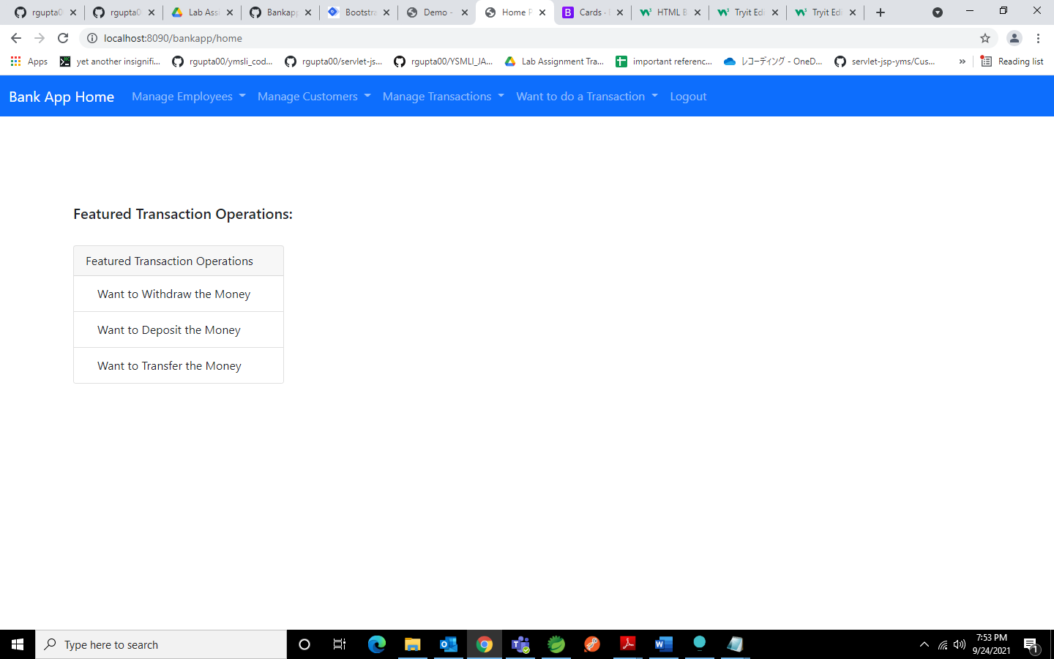

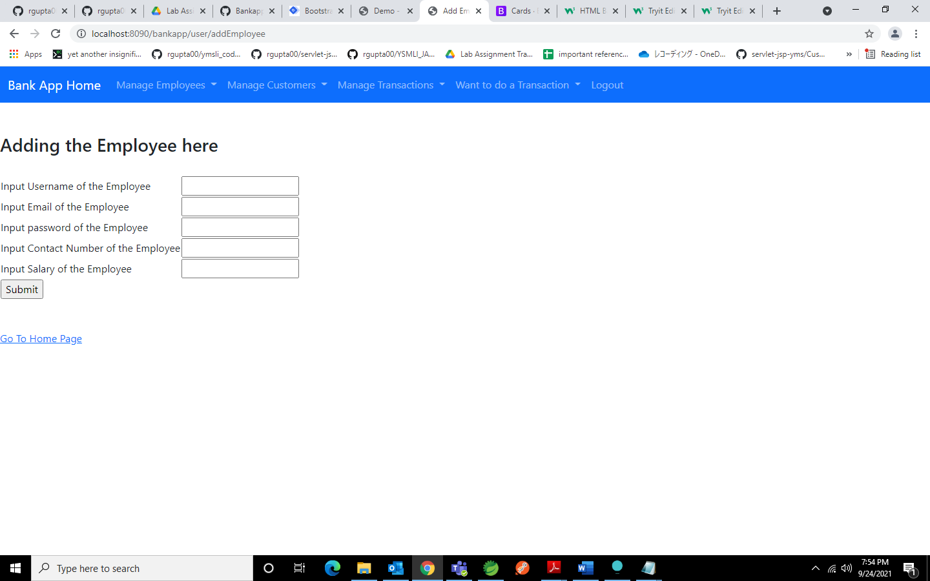

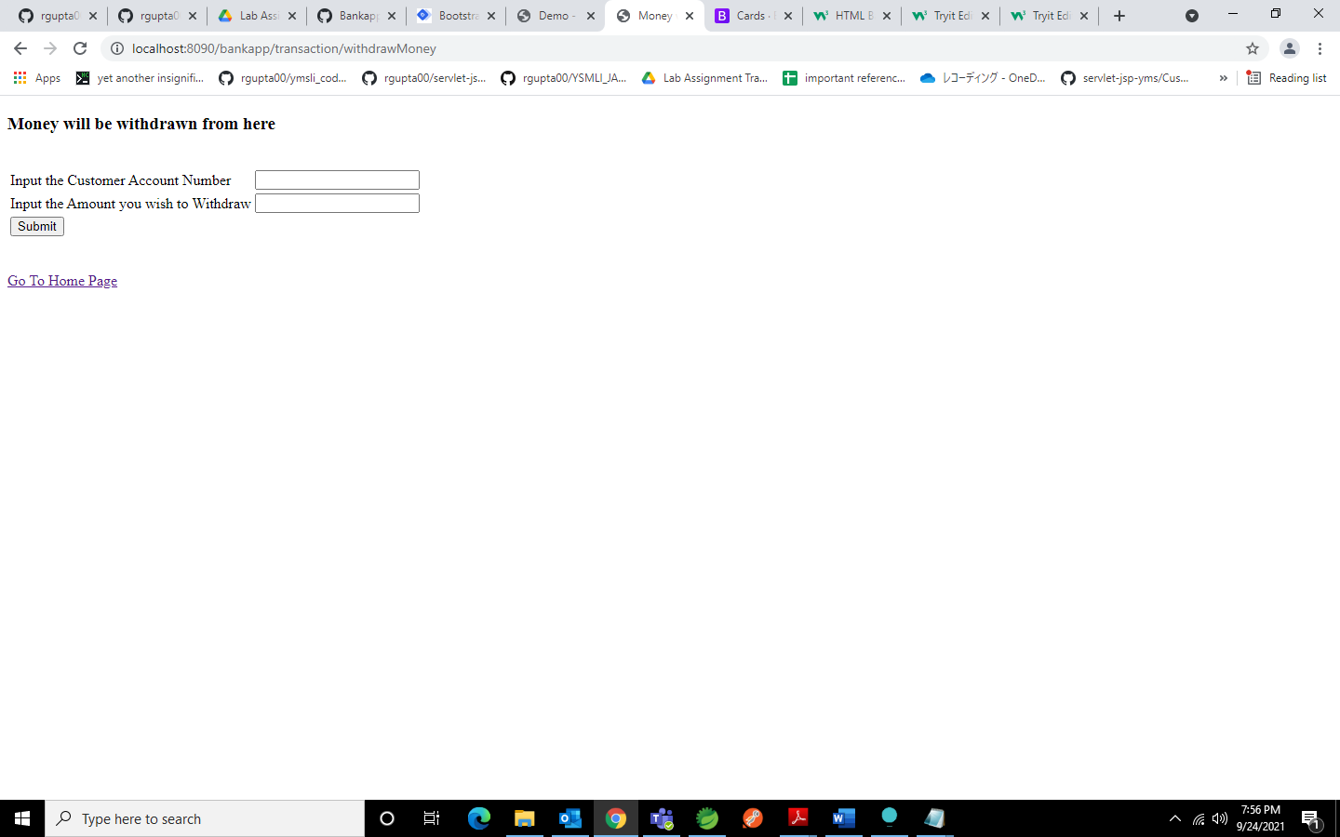

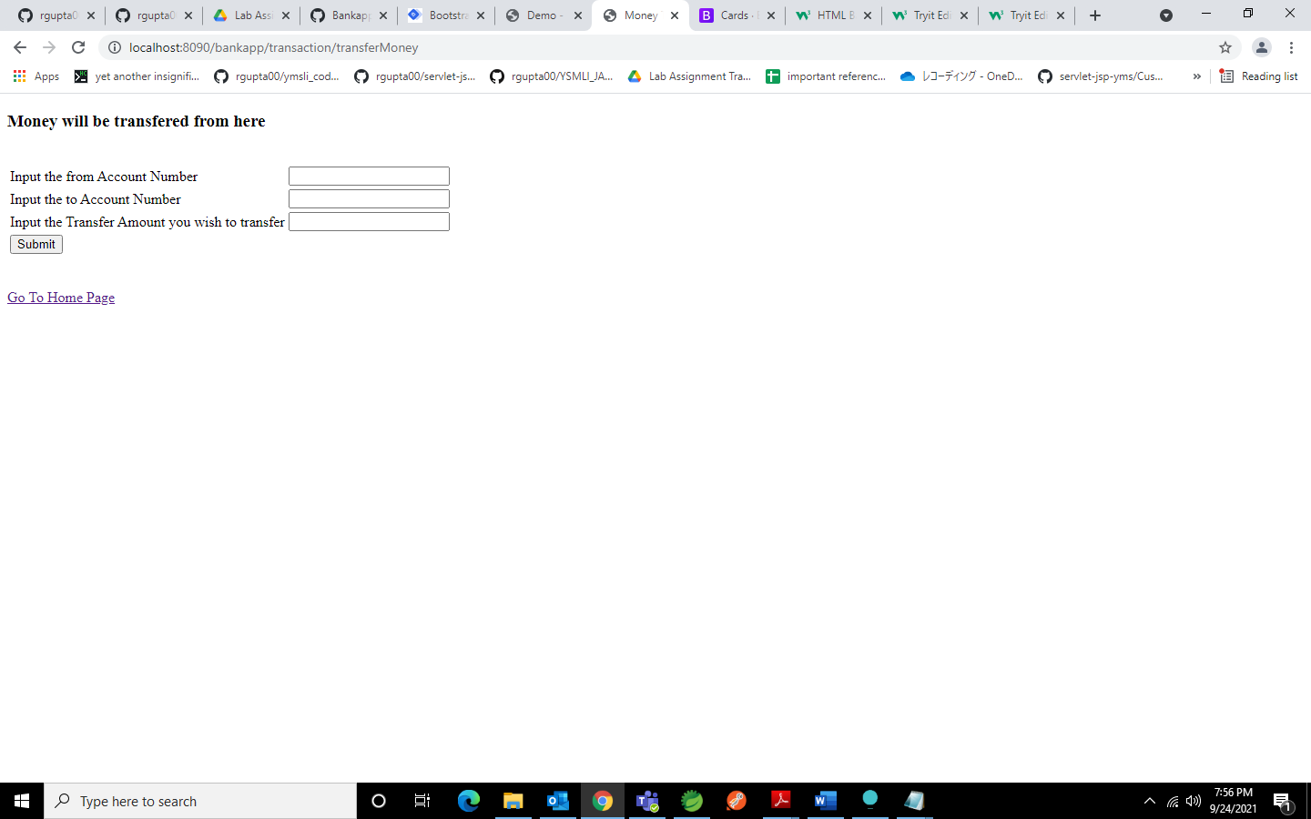

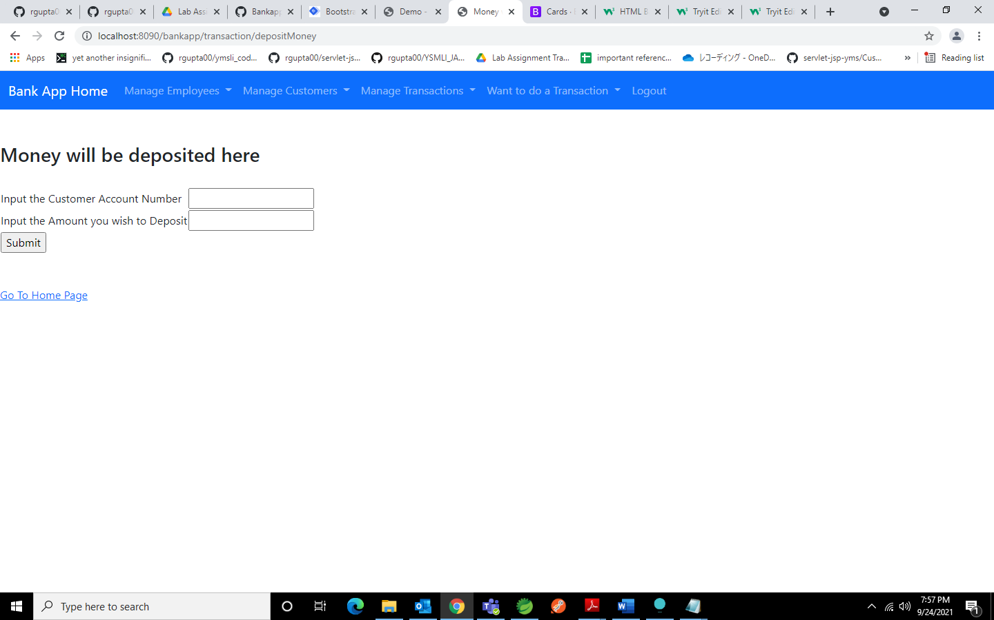

**REFERENCES**

* <https://docs.spring.io/spring-framework/docs/current/reference/html/>
* <https://docs.spring.io/spring-boot/docs/current/reference/htmlsingle/>
* <https://www.baeldung.com/spring-boot-jsp>
* https://stackoverflow.com/